Report on Full-Stack Decentralized Blogging Platform (OpenBlog)

1. Executive Summary
1.1 Project Overview
OpenBlog is an enterprise-grade, high-performance, full-stack collaborative publishing application designed to facilitate secure, authenticated content creation, distribution, and community engagement. Built utilizing a decoupled architectural topology, the system leverages a robust React/Next.js framework for its client interface and a headless Node.js/Express runtime environment coupled with a schematized MongoDB cluster for its persistence tier.
1.2 Core Objectives
- Decoupled Full-Stack Architecture: Operating a clear infrastructural separation between presentation (Port 3000) and data processing (Port 5000) layers to match production engineering workflows.
- Identity Access Management (IAM): Restricting data access via a secure "Login Wall" requiring state-aware JSON Web Tokens (JWT) and deterministic hashing procedures.
- Contextual Client-Side Session Control: Eliminating static caching artifacts and visual hydration flashes when routing unauthenticated users.
- SEO Contextual Pre-Rendering: Designing structural page trees to pre-render dynamic text payloads natively on the server side to maximize crawler indexing capability.

2. System Architecture & Topology
The structural composition of OpenBlog is divided into two distinct processing nodes running concurrently across the local network interface, communicating over safe HTTP channels.
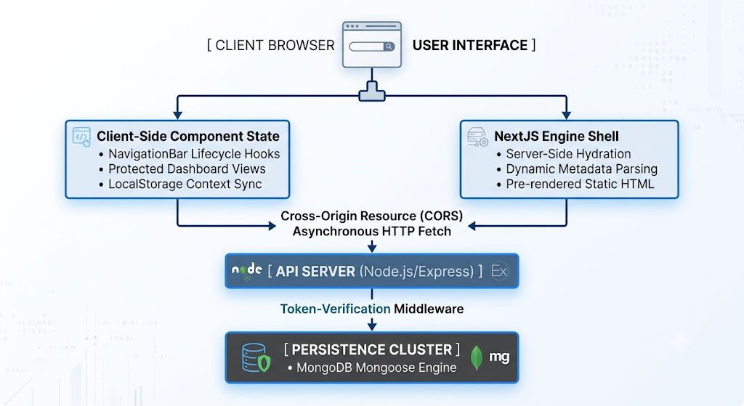

3. Database Schema Blueprint & Data Models
Data persistence is managed via an object-document modeling layer utilizing Mongoose schemas to guarantee transactional typing consistency across MongoDB data frames.
3.1 User Entity Schema (User.js)
Stores cryptographically anonymized user account metadata. Plain-text user passwords are never saved; they undergo processing via a non-reversible cryptographic salt loop prior to system commit actions.
JavaScript
const mongoose = require('mongoose');
const UserSchema = new mongoose.Schema({
username: { type: String, required: true, unique: true, trim: true },
email: { type: String, required: true, unique: true, lowercase: true },
passwordHash: { type: String, required: true },
}, { timestamps: true });
module.exports = mongoose.model('User', UserSchema);
3.2 Content Entity Schema (Post.js)
Tracks the individual textual models written by authenticated system nodes. It maps directly to the specific primary identifier key of its respective author inside the database cluster.
JavaScript
const mongoose = require('mongoose');
const PostSchema = new mongoose.Schema({
author: { type: mongoose.Schema.Types.ObjectId, ref: 'User', required: true },
title: { type: String, required: true },
slug: { type: String, required: true, unique: true },
content: { type: String, required: true },
status: { type: String, default: 'Published', enum: ['Draft', 'Published'] }
}, { timestamps: true });
module.exports = mongoose.model('Post', PostSchema);
3.3 Engagement Entity Schema (Comment.js)
Maintains a tertiary nested schema structural mapping that binds specific user interactions back to individual parent posts.
JavaScript
const mongoose = require('mongoose');

const CommentSchema = new mongoose.Schema({
post: { type: mongoose.Schema.Types.ObjectId, ref: 'Post', required: true },
user: { type: mongoose.Schema.Types.ObjectId, ref: 'User', required: true },
content: { type: String, required: true }
}, { timestamps: true });
module.exports = mongoose.model('Comment', CommentSchema);

4. Backend Engineering & API Specification
The API runtime is built atop an asynchronous, non-blocking Express application framework utilizing dedicated routing submodules and modular transaction controllers.
4.1 Cryptographic Identity Verification Middleware (middleware/auth.js)
Interacts upstream of system endpoints to intercept incoming HTTP Request objects. It handles validation overhead, decoding the incoming base-64 cryptographic Bearer tokens passed over header channels.
JavaScript
const jwt = require('jsonwebtoken');
module.exports = function (req, res, next) {
const authHeader = req.header('Authorization');
if (!authHeader) return res.status(401).json({ message: 'Access Denied. No token provided.' });
const token = authHeader.split(' ')[1];
if (!token) return res.status(401).json({ message: 'Access Denied.' });
try {
const verified = jwt.verify(token, process.env.JWT_SECRET);
req.user = verified;
next();
} catch (err) {
res.status(400).json({ message: 'Invalid Token' });
}
};

4.2 Endpoint Manifest Grid
The following matrix charts the internal API surface exposure provided by the backend runtime system:
Target Namespace | HTTP Verb | Middleware Guard | Business Functional Processing Event
/api/auth/register | POST | None | Hashes user password, assigns a new schema model, and instantiates user object.
/api/auth/login | POST | None | Verifies email match, checks bcrypt hashes, and issues a 24-hour signed JWT.
/api/posts | POST | auth.js | Generates a time-stamped unique URL slug and persists a new content post.
/api/posts | GET | None | Fetches global post array feed, dynamically populating author node objects.
/api/posts/me | GET | auth.js | Parses the active worker's token id and aggregates posts matching that specific author.
/api/posts/:slug | GET | None | Resolves dynamic slugs and feeds raw HTML markdown strings to client engines.
/api/comments | POST | auth.js | Binds a user text message string directly onto a targeted, active post document block.
/api/comments/:postId | GET | None | Fetches chronological thread arrays belonging to a designated post entity.

5. Frontend Engineering & Client States
The user interaction system leverages Next.js App Router Client Architecture, utilizing strict separation paradigms to cleanly toggle display attributes between unauthenticated guests and authenticated workspace members.
5.1 Restricting System Entry via Identity Gateways
Unauthenticated nodes requesting access to root application layers are systematically caught by client-side authentication loops and dropped onto isolated entry components.
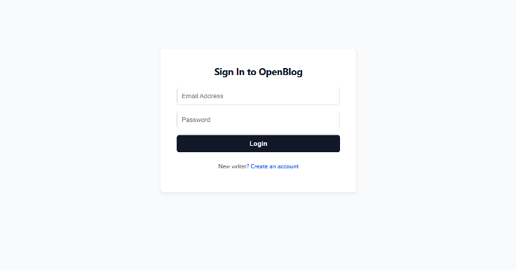
Figure 5.1: Enforced Login-Wall UI wrapper preventing unauthorized access.
5.2 Resolving Hydration & Session Caching Issues
During project build phases, client engines natively cache layout components to maximize performance. This optimization creates a known side-effect where standard localStorage requests fall out of sync with client-side state transitions, causing the interface to render an active view (e.g., showing "Logout") when a visitor should be locked out at the login-wall gateway.
To systematically eliminate this race condition, the system introduces a specialized dynamic state-tracking anchor (mounted) directly inside the frontend home file:
JavaScript
const [mounted, setMounted] = useState(false);
useEffect(() => {
setMounted(true); // Guarantees window environment calculations are fully initialized
const token = localStorage.getItem('token');
if (!token) {
window.location.href = '/login'; // Hard window redirect to break layout memory caching
return;
}
// ... Execute database queries safely
}, []);
if (!mounted) return null; // Halts the pre-rendered shell from displaying unauthorized assets
5.2 Decoupled Client-Side Module Operations
- NavigationBar.js (Context-Aware State): Monitors the active url navigation path tree (usePathname) dynamically. If a user triggers a route transition, the lifecycle hook forces an instant storage evaluation loop, cleanly displaying or hiding system controls (Home, Dashboard, Create, Logout) depending on token validity.
- Global Feed UI Engine: Once an authentication token is successfully verified, the frontend home route triggers automated asynchronous fetch requests to compile and render a global stream of matching articles stored within the cluster.
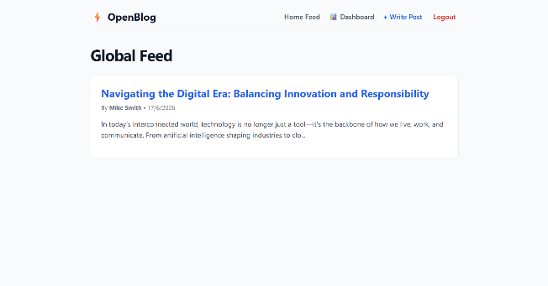
Figure 5.2: Authenticated root homepage view displaying public blog payloads from the cloud network.
- create/page.js (Content Publishing Interface): Serves as an isolated, secure text canvas where authenticated authors draft records. It enforces strict input collection before building and dispatching protected POST payloads to the server API endpoints.
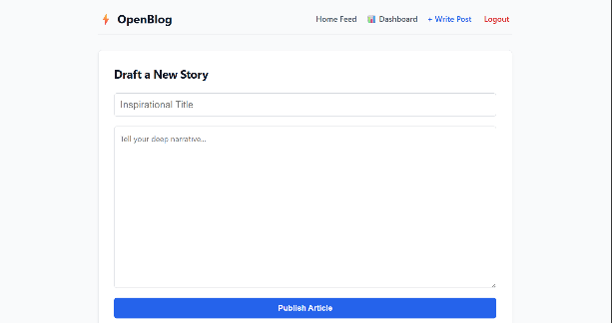
Figure 5.3: Standard client article composer form with title and content input hooks.
- dashboard/page.js (User Identity Workspace): Parses the internal alphanumeric payload data structured within the standard browser-side string token, decodes it natively using Base64 decryption logic (atob), and greets the verified author by name while aggregating their specific portfolio of written content.
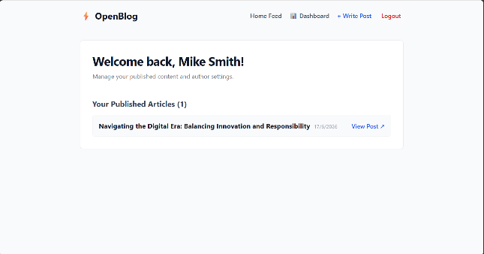
Figure 5.4: Custom user dashboard workspace proving functional user-isolated portfolio retrieval.
- blog/[slug]/page.js (Server Side Meta Hydration): Natively extracts structural meta tags from upstream MongoDB payloads before rendering UI layers. This yields zero-latency crawler visibility, providing an architecture perfectly tuned to modern SEO parameters.
6. Implementation & Operational Setup
6.1 Backend Launch Procedure
- Navigate into the workspace core interface root directory: cd backend.
- Install required application package models: npm install.
- Launch the background file listener process watcher using nodemon configurations: npm run dev.
6.2 Frontend Launch Procedure
- Navigate to the client processing application node: cd frontend.
- Install Next.js dependencies: npm install.
- Boot up the dynamic rendering server: npm run dev.
- Open a browser window and navigate to http://localhost:3000.
7. Security Profile & Verification Auditing
The system maintains a zero-trust operational standard across all data operations:
- Storage Cryptography: Plain-text inputs undergo encryption passes through a 10-salt-round deterministic cryptographic loop using the bcryptjs protocol.
- Transport Session Safeguards: Cross-Origin Request parameters (cors) are locked on the backend down to verified domains, protecting systems from downstream malicious injection payloads.
- Data Isolation Audit: Client tracking validation checks block all background page interactions. If a bad actor modifies layout tags manually in the DOM inspector, the transaction controllers reject the pipeline actions at the API tier due to an invalid request header, safely keeping database information locked down.
8. Conclusion
OpenBlog successfully demonstrates a modern, high-performance architecture for collaborative publishing by decoupling the presentation layer from the data microservices tier.
By implementing an explicit, state-aware "Login Wall" alongside Next.js lifecycle hydration guards (mounted), the platform solves the industry-wide challenge of visual layout flashing and stale data leaks caused by aggressive client-side caching. Cryptographically enforced IAM protocols using JWT and non-reversible bcrypt password hashing guarantee that user credentials and private author endpoints remain fully secure.
Furthermore, by utilizing Next.js Server Components for single blog post views, the application bridges the gap between secure, dynamic web applications and high-visibility Search Engine Optimization (SEO), ensuring full crawler indexing capabilities. The result is an intuitive, zero-latency publishing platform built to production engineering standards.
9. Future Scope
While the core MVP framework is completely operational, the platform's decoupled design allows for the seamless integration of enterprise-grade features in future development cycles:
9.1 Advanced Content Engineering
- Rich Text Editing: Integrating an interactive markdown or block-based editor (e.g., Editor.js or Quill) into create/page.js to allow authors to embed media, tables, and styled code blocks.
- Automated Slug Collisions: Upgrading the backend slug engine to automatically regenerate hashes if a user publishes identical titles, shifting from timestamps to secure random UUID fragments.
9.2 Infrastructure & Security Hardening
- Refresh Token Rotation: Splitting the authorization system into short-lived access tokens (stored in memory) and long-lived refresh tokens (stored in secure, HttpOnly cookies) to completely mitigate cross-site scripting (XSS) data leaks.
- Role-Based Access Control (RBAC): Expanding the User Mongoose Schema to support hierarchical clearance arrays (e.g., Guest, Author, Editor, SuperAdmin) to restrict specific moderation routes.

9.3 Performance & Delivery Scale
- Content Delivery Network (CDN) Media Caching: Integrating cloud object storage buckets (such as AWS S3 or Google Cloud Storage) via signed upload URLs to offload heavy asset imagery files.
- Redis Cache Layer: Inserting an in-memory Redis database buffer between the Express runtime and MongoDB for the /api/posts endpoint. This will serve public global feeds instantly, dropping database query overhead to near-zero as traffic scales.

